1) Find the top 20 zip codes(hint: branch_zip) by total transaction value

USE credit_card_system;

SELECT BRANCH_ZIP, SUM(TRANSACTION_VALUE) AS Total

FROM CDW_SAPP_D_BRANCH B JOIN CDW_SAPP_F_CREDIT_CARD T

ON B.BRANCH_CODE = T.BRANCH_CODE GROUP BY BRANCH_ZIP

ORDER BY Total DESC LIMIT 20;

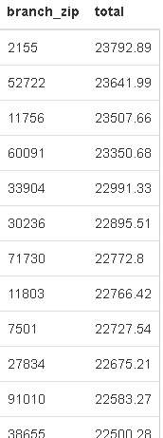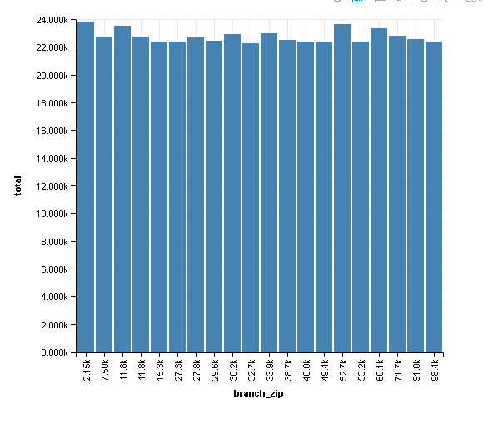

2) Find total transaction value for each transaction type by Quarter in 2018

SELECT QUARTER,TRANSACTION_TYPE,SUM(TRANSACTION_VALUE) AS Total

FROM CDW_SAPP_F_CREDIT_CARD T JOIN CDW_SAPP_D_TIME TI

ON T.TRANSACTION_ID = TI.TRANSACTION_ID WHERE TI.YEAR = 2018

GROUP BY QUARTER, TRANSACTION_TYPE ORDER BY QUARTER;